**Captains’ Weekly Newsletter #1**

HeiMoi!

You have just received your first Captains’ Weekly newsletter, awesome! But what even is this and what is the difference between this and all the other mailing lists and groups?

The Captains’ Weekly newsletter is the main information channel from your Fuksi Captains to you, which gets sent every Sunday evening. In the newsletter, we collect together general things for you to remember and information about events organized by PT, CHEM, and other organizers. Additionally, there is information about Fuksi Points and upcoming possibilities to collect them.

In addition to the newsletter, there is information available on Telegram via Captains’ Channel and PT’s Information Channel, as well as PT’s own weekly newsletter. However, the newsletter for all PT members often omits the essential information and events directed for fuksis, so we recommend focusing mainly on the Captains’ Weekly as your source of information. The Captains’ Channel on Telegram is used mainly for faster updates on information and reminders. In order to get the most information as early as possible, make sure to read this newsletter.

Remember to apply for PT’s membership [here](https://prosessiteekkarit.fi/en/membership/), for example, because our events are only for members. Also, remember to join the [PT Fuksis 2022](https://t.me/+cDQIRSFN-hAwODQ0) and [Captains’ Channel](https://t.me/+NYO-pJq85SNiYmI0)  -Telegram groups.

**Contents**

**I** **Common things to remember**

1. Get your PT’s membership
2. PT’s weekly newsletter for members
3. PT’s Telegram-group and information channel
4. Pay the students’ healthcare fee if you haven’t already!

**II** **Events arranged by PT and CHEM**

1. Grill’n’Chill CANCELLED
2. Cold rolling 12.9.
3. Otatarha Grand Prix 2022 -lecture
4. Heat Transfer IX 17.9.
5. Save the date: FuksiSitsit 22.9.

**III** **Other events**

1. Aalto Party and Afterparty 6.9.
2. Stadisuunnistus 8.9.

**IV** **Fuksi Points**

1. Compulsory points
2. Voluntary points

**V Greetings**

[(ylös)](https://docs.google.com/document/d/12eVWZCjfHyeAFslzx_H5R24DLIV3ULF8/edit#heading=h.4d34og8)

# Common things to remember

## Get your PT’s membership

If you didn’t pay the membership fee for Prosessiteekkarit, you can fill the membership application [here](https://prosessiteekkarit.fi/en/membership/). The payment information will be sent to your email address.

## PT’s weekly newsletter for members

You can join the PT mailing list at <https://list.ayy.fi/mailman/listinfo/pt-info>. This mailing list is used to inform members about upcoming events and other current affairs. A weekly bulletin is sent to the list every Monday, and by reading it actively you will be aware of the current student activities of the association and the rest of Otaniemi.

## PT’s Telegram-group and information channel

Do you want to follow and participate in discussions regarding all PT members? Do you want to hear the ideas and thoughts of students from other classes as well? To do this, there is #PT, a common Telegram group to all PT members.

You can join the General Discussion Group #PT on Telegram from [this link](https://t.me/+7hR6OekaJ0owMTU0). The group is for both formal information and informal discussion. Please read the group rules when you join the chat.  
  
In addition, PT has its own one-way information channel on Telegram, which works with the same principle as Captains’ Inform. It’s used for informing about events and condensing the weekly newsletter for all members. You can follow the information channel [here](https://t.me/+n-rYO6zze2sxNzQ8).

## Pay the students’ healthcare fee if you haven’t already!

In 2022, the student healthcare fee in higher education is EUR 35.80 per term. It is paid to Kela once per term (spring and autumn), i.e., twice a year. Students are not billed for the fee but are expected to pay it on their own initiative. The amount that must be paid is defined in a Government Decree and may vary from year to year. More information can be found [here](https://www.kela.fi/web/en/healthcare-fee-for-students-in-higher-education). The deadline for the payment was 30.9. but you can still do it if you didn’t already!

[(ylös)](https://docs.google.com/document/d/12eVWZCjfHyeAFslzx_H5R24DLIV3ULF8/edit#heading=h.4d34og8)

# Events arranged by PT and CHEM

## Grill ‘n Chill CANCELLED

We have begrudgingly decided to cancel Grill’n’Chill due to the unfortunate position of the stars in relation to Venus (in other words, the “Grill” part of the event is malfunctioning). We aim to arrange an alternative event to allow you to earn the Grill’n’Chill fuksi point later during the fall.

## Cold Rolling 12.9.

Lämmönsiirto week is approaching and so is the traditional Cold Rolling!

Do you want to try out a new ball sport? Or perhaps show off your beach volley skills? This year’s Kylmävalssaus offers you a chance to play Kin-ball and Beach volley. In honor of Lämmönsiirto X, Prosessiteekkarit will head out to the beaches of Salmisaari on Monday the 12th of September at 15-16.30. Kin-ball is played in a tournament fashion in the event, and Beach volley at the players own pace on the side. After the games participants can use the saunas at the location. Participation costs 8€/person and there are 30 spots for participants. The sign up opens 1.9. at 12.00 and closes 9.9. at 23.55 here. The sign-up becomes binding after closing!

## Otatarha Grand Prix -lecture 13.9.

The traditional Otatarha Grand Prix is held on the last day of September, and you as fuksis have to build a cart! For this job you have to be thoroughly coached and trained, and TuNa is hosting an information lecture about it after one of your lectures! Further information will be posted in next week’s Captains’ weekly, and in the Captains’ Inform -telegram channel!

## Catalysis 15.9.

As the tenth year also deserves a party of the decade, the Lämmönsiirto Week reaches an energy peak already well before the annual ball! The Catalysis raises the energy levels of the reaction to a whole other level, you won’t want to miss this! More information on the event will be posted on next weeks newsletter!

You can earn the Lämmönsiirto Party -fuksi point from this event!

## Save the date: FuksiSitz 22.9.

*NOTE! This event will be held mostly in Finnish, there will be an English Bachelor FuksiSitz held entirely in English on the 22nd of October!*

On the 22nd of September, the PT FuksiSitz will be held in Servin Mökki (Smökki). The FuksiSitz will be the first sitz you attend, and a unique opportunity to introduce yourself to the rich and varying sitz- and singing culture of Otaniemi. FuksiSitz are a formal event with a three course meal, music performances and much more!

Before the sitz there will be an optional cocktail event held in the Museum of Student Life (Jämeräntaival 3). The cocktail event starts at 5pm, and you can come whenever you like and have a look around. The main event starts at 6.30 pm sharp at Smökki when the gong is rung. After the main event, the Afterparty will also be held in Smökki. The event will cost 20€ in its entirety and payment information will be delivered via email after the registration closes.

**The registration for the sitz begins on the 7th of September at 12:00** in PT’s registration page, Ilmomasiina, and closes at 14.9. at 23:55. You can leave requests for one person to be your seating company (First name + Surname). After the registration closes your registration is binding.

Fuksisitz follows Aalto University Student Union’s (AYY) Safer Space Policy. Event aims to be equal and comfortable for everyone. If you see or experience inappropriate conduct, you have the right to intervene in the situation. If you wish, you can also get in touch with AYY’s harassment contact persons: hairinta@ayy.fi

kuukle kääntäjä mikä on korvapuusti

jätä tää tänne Mut kopsaa toi valmis juttu ilmomasiinaan? je! joo YE>H

pitääks tldr laittaa wiikkikseen saako poistha poista mietin samaa kans ent toi reilu tapahtuma juttu ku sehä tulee siihen ilmotekstiin ok lit aivan lol voin poistaa totta ehk vähän turha tai emt? vitun häryfukseja

[(ylös)](https://docs.google.com/document/d/12eVWZCjfHyeAFslzx_H5R24DLIV3ULF8/edit#heading=h.4d34og8)

# Other events

## Aalto Party and Afterparty 6.9.

The festival-like Aalto Party gives you the opportunity to see old friends and make new ones while enjoying the music and party atmosphere at Alvar Aallon puisto. Don’t miss the first party of the academic year – a day when all professors, staff and students meet in the same event.

Aalto Party includes various programmes and, of course, the traditional tug of war between the board of AYY and Aalto University's management team is something not to be missed, around 15.30 close to the AYY tent.

Aalto Afterparty makes a comeback in the middle of the solar system, in Otaniemi, after three years. During the evening, top artists will lift everyone’s party mood through the roof all the way to space.

In addition to the musical experiences, you’ll get to enjoy the bar and other fun activities. So head to Dipoli for one of the biggest parties of the school year!

The event is only for students older than 18.

## CityOrienteering 8.9.

Dear Fuksis,

The time for the traditional CityOrienteering arrives on Thursday the 8th of September! In this sister event to last week’s OtaOrienteering, you get to take over the Eastern Harbour Town, also known as Helsinki. In our beautiful capital, you will be greeted by checkpoints and missions held by our wonderful associations and student nations. You’ll get to explore these checkpoints in groups of 5-8 people, and simultaneously get to know our beautiful neighbouring city.

The grand start for the even is held at the Senate Square at 5.15 pm. Be there on time! The event ends in the same place at 9 pm, after which we will move on indoors for the after party.

The entry ticket to the after party will be a wrist band that will be given to you at the grand start. You can simultaneously buy yourself the overall patch for the event from the Fuksi Committee for 2€ using cash or Mobilepay.

Wishing you luck with starting your studies,

*Henri Brax*

*Fuksi Major*

[(ylös)](https://docs.google.com/document/d/12eVWZCjfHyeAFslzx_H5R24DLIV3ULF8/edit#heading=h.4d34og8)

# Fuksi Points

Here’s a reminder about the compulsory fuksi points in order to get your teekkari cap and chances to get them. Here are listed some elective points and notifications. Explanations for all the fuksi points will be available on our website [here](https://prosessiteekkarit.fi/en/fuksi-points/)!

## Compulsory points

**10 Credits:** Earned by gathering 10 credits during the academic year. Piece of cake!

**The Great Work Point:** Earned by working a 6 hour work shift at a big event, primarily PT’s or other CHEM Guild’s annual ball.

**Association meeting:** Earned by attending one association meeting. The members will be informed about these via email 2 weeks prior.

**Museum visit:** A guided tour of the Museum of Student Life! More information will be given later.

**Song exam:** A relaxed singing session with TuNa, More information will be given later.

**CapChat:** A relaxed chat with TuNa, times to be reserved later.

**Fuksi Jäynä:** More information will be given later.

## Elective points

**Grilli ‘n Chill:** Info on a compensatory event will be posted later!

**Lämmönsiirto Party:** Attend the Catalysis -event on Thursday the 15th! This event can be found on the point card!

**Cold Rolling:** Attending the Cold Rolling can earn you a free point onto the empty lines!

**Mystery Point:** The Great Siivilä is still in the tight grip of the Guild of Phyiscs, go and steal it back to its rightful owners, and document your heist!

# Greetings

**Anna:** Wow, what an incredible run, you did it! It was so wonderful to get to see you all and follow along, you completed the whole week with such amazing energy! I spend the rest of the week lying in bed with the flu, but I’m saving up energy to go full blast again next week! As I await the start of studies with a mix of fear, I am comforted and energized by one song and one song only, [Shanghain valot](https://open.spotify.com/track/774tMmxHPUdEOVJgr9rXGU?si=463637ceec4a4bb2)! See you next week :)

**Eetu:**Thanks for the amazing orientation week! It was great getting to meet all of you, hope you had fun! The last couple of days I’ve been recovering from the flu, but on Monday I should be ready for another great week! Next week there’s a lot to do, and there's already the first lectures to attend too! Until tomorrow I’ll just hang out with my cat and my partner :)

Weekly picture of Nugget:

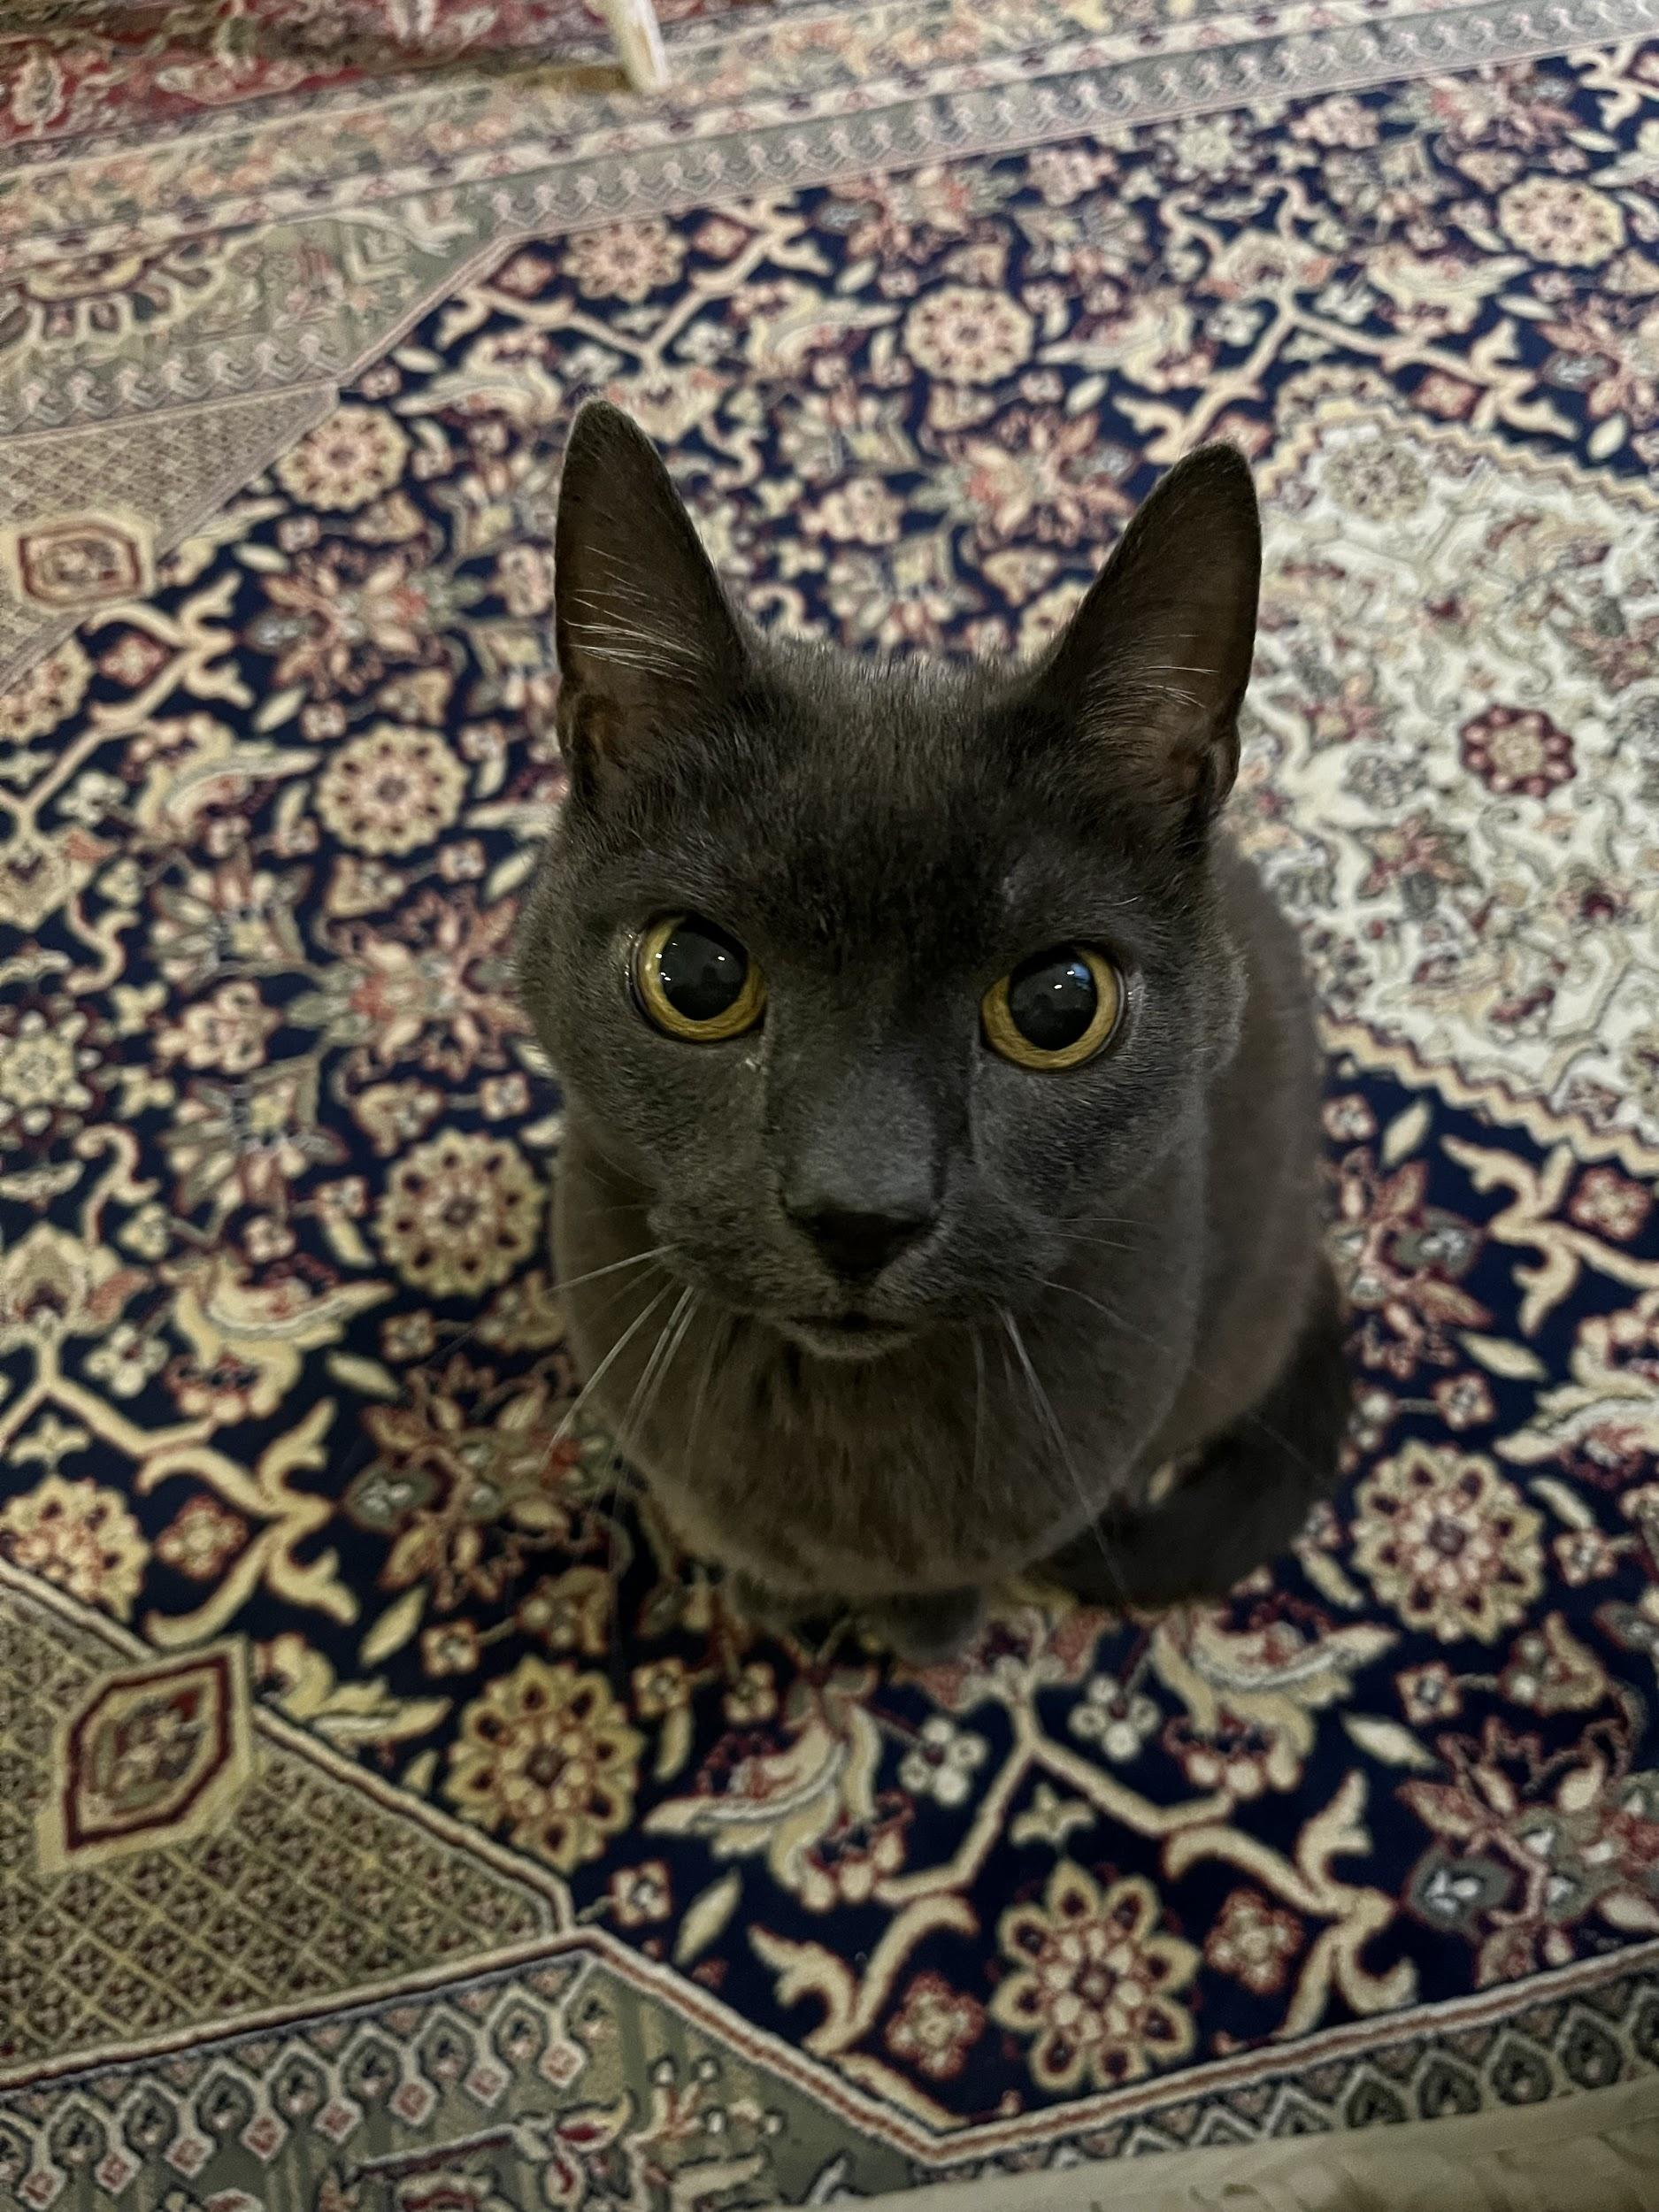

**TuNa**

P.S Good luck to the first real study week for all of you guys!